Statement of support for His Holiness the 14th Dalai Lama by Tibetan Allopathic Physicians Network

We, the undersigned members of the Tibetan Allopathic Physicians Network have been deeply saddened by how His Holiness the Dalai Lama has recently been the subject of much controversy and misunderstanding. We feel that there has been gross misrepresentation and misunderstanding, which has led to unjustified defamation and slander.
As medical professionals, we are always mindful of the importance of safeguarding children and of our responsibilities in this regard. We understand the nature of the concerns raised. However, we also possess a broad collective knowledge of His Holiness the Dalai Lama, his ethics, teachings and significant contributions to humanity which include establishing the foundations of popularising mindfulness and developing frameworks for social, emotional and ethical learning.
In all of this, we have unwavering confidence in His Holiness the Dalai Lama and the lack of anything other than his unparalleled and sincerest of altruism towards all, regardless of age, gender, race, religion and disability. This is based on our collective and continuous years of direct and extensive observations and includes the professional contact had by Dr.Sadutshang, His Holiness’s personal physician who has worked closely with him over 35 years and observed at first-hand the Dalai Lama’s integrity, humour and playful nature. We are cognisant of his rudimentary use of the English language and know that whilst we may be familiar with how certain words, across languages can have different connotations and loaded meanings, these subtleties and nuances will not be familiar to an 87 year old celibate monk living an austere, monastic lifestyle. We are confident beyond a shadow of doubt, that there was no intent of harm, let alone that of a sexual nature.
We recognise that social displays of platonic affection may vary between world communities, however, whilst these may be perceived differently, especially when taken outside situational and cultural contexts, this does not equate to acts of harm. We recognise that culture alone is not an excuse for any risk posed to the welfare of a child, however, one must consider if any harm has taken place at all. Given the situational context, the absence of any complaints from those present on the day, the expression of a positive experience by the boy and his family after the event stands in good faith, supported by the lack of evidence of any harm experienced by the child or the family since the event. We feel that there have been serious and irreparable implications of this misunderstanding not just for His Holiness but also for the lives of the child and his family trying to reconcile the positive experience with the calumny in the media.
It has been a period of immense mental and emotional distress for millions of Tibetans and well wishers of His Holiness worldwide. We are beginning to learn of an increase of cases with disorders of mood, anxiety, insomnia and tearfulness. We hope that the affected population at large can find comfort in the tremendous effort they have made in clarifying the misunderstanding and begin to heal by drawing strength and support from each other and where needed, access psychological support. No one will challenge the importance of safeguarding children; however, the incident in question was not an act of child abuse. Nevertheless, despite this incident, our people are learning that serious misunderstandings can occur. We hope the world learns that any assessment of such situations needs to be culturally and contextually informed and that together, we continue to learn about each other’s cultural sensitivities.

Dr.Tsetan Dorji Sadutshang, MBBS, DTM&H, DTCD, MPH, FRCP
Chief Medical Officer, Delek Hospital, Dharamsala, India
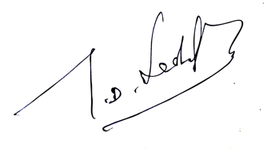

Kunchok Dorjee, MBBS, PhD, MPH
Assistant Professor of Medicine and International Health
Johns Hopkins University, Baltimore, USA
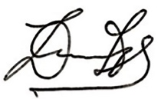

Dr Dhondup Tashi
Chief Medical Officer
Gaden Jangtse Hospital, Mundgod, India
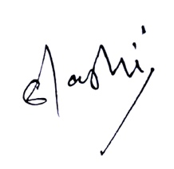

Dr.Sonam P. Kundeling MD
Vice President, Renal Medicine Associates, Albuquerque, NM, USA
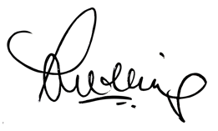

Dr. Tenzin Y. Takla, MBBS, BSc, DRCOG, MRCGP
General Practice Partner and Safeguarding Lead, London, UK
Dr.Dechen Tsewang, MD
Family Physician, Santa Fe, NM, USA
