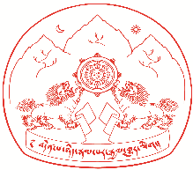

Sikyong Award for Academic Accomplishment - 2018:

Any Tibetan student who has completed Ph.D in any field since August 2017 will be awarded the Sikyong Award of Rs.20,000 along with a certificate of appreciation. The applicant for Sikyong Award must submit the following documents to DOE by August 15, 2018:
1. Attested Copy of first and last page of applicant's Green Book.
2. Attested Copy of Ph.D Certificate
3. Copy of Ph.D Thesis

The Sikyong Award will be given during the Tibetan Democracy Day Celebration, September 02, 2018, at Tsuklagkhang, Dharamsala. To receive this award, the following allowances will be made by DOE for which the original bills must be produced:
a. Travel by AC II Tier Train or AC Bus
b. Dearness Allowance of Rs.300/- per day
c. Room Rent allowance of Rs. 500/- per day

Submit applications to:

Secretary
Department of Education
Central Tibetan Administration
Gangchen Kyishong
Dharamsala - 176215
Distt. Kangra
Himachal Pradesh, India
Ph: 01892 - 222572, 222721, 226695
E-mail: doe.lobyon@tibet.net or scholarship@tibet.net
www.sherig.org / www.lamton.org Posted: July 17, 2018

